**COS420 – Practice – Requirements, Use Cases and Sequence Diagrams**

College Jobs description:

College Jobs is a job listing aggregator designed to help college students find part time and freelance jobs with good pay that will further the skills they are learning in college. Our users will be able to search for part time jobs *and* freelance work on the same site, and the platform will automatically filter out jobs that are not compatible with the requirements of students in college.

1. Write 5 functional and 5 non-functional requirements for the college jobs

FR:

1. The system must show job listings in data related fields
2. *The system must provide a privacy setting, such as who can view the users profile. Options being just registered users, only the users themselves, or public.*
3. *The system will not allow unverified users from applying to jobs*
4. *The system will have an option to filter work opportunities by a filter button*
5. *The system will scrape for job listings*

NFR:

1.The system shall allow users to use the system 5 seconds following registration.

2. The system shall have an at least 99.9% uptime.

3. The system shall have a search functionality that returns results within 5 seconds 95.9% of the time.

4. The system shall be available for 24hrs a day, 7 days a week to all users, 99% of the time.

5. The system should limit the photo file size to 500MB.

1. Derive use cases from the requirements you produced in 1.

use cases:

UC1. Create Account (a solution may or may not include this use case)

UC2. Job Feed

UC3. Filter Job

UC4. Apply for Job

UC5. Bookmarking/saving a job listing

UC6. Add Company Description to Account

UC7. Freelance Job Offerings

UC8. Job for Credits

UC9. Retrieve Listing Updates

UC10. Set Job preferences

UC11. Add Skills to Profile

UC12. View all company listings

1. Draw use case diagrams.

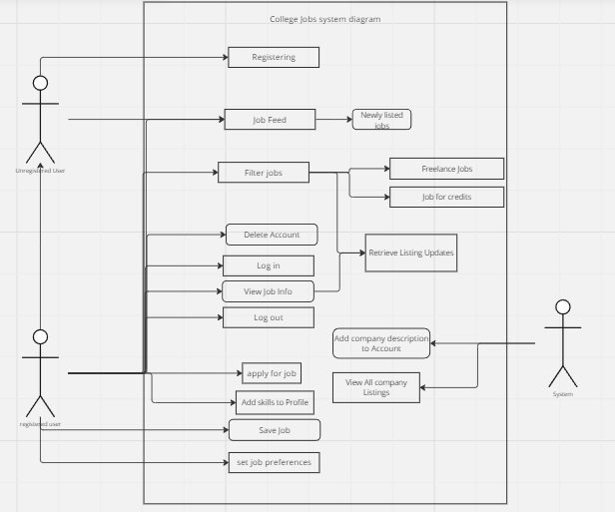

1. Write use case descriptions for College Jobs

| **USER STEPS:**  1. Clicks on a relevant job listing  3. Click the “Save” or “Bookmark” button  5. User sees a confirmation message. | | **SYSTEM RESPONSE:**  0. Show a list of jobs  2. Shows information about the job listing, and displays a “Save” or “Bookmark” button  4. Displays a notification indicating it has been saved | |
| --- | --- | --- | --- |

| **USER STEPS**:  1. The user opens search menu  3. Users click a company.  5. User picks all company listings. | **SYSTEM RESPONSE**:  2. System shows search menu  4. The system shows the company page  6. System returns all of the company’s listings. |
| --- | --- |

1. Create scenario tables, analysis sequence diagrams, or design sequence diagrams for College Jobs

**Scenario tables**

| **Step #** | **Subject** | **Subject Action** | **Parameters** | **Object Acted Upon** |
| --- | --- | --- | --- | --- |
| 3 | User | “Click” Save Job | Job | Job GUI |
| 4.1 | Job GUI | Save Job | Job | Job Controller |
| 4.2 | Job Controller | Add To List of SaveJobs | Job | DB Manager |
| 4.3.1 | if save successfully |  |  |  |
| 4.3.2 | Job Controller | create message | "Job has been saved" | Message |
| 4.3.3 | Job GUI | display | message | Customer |
| 4.3.4 | else |  |  |  |
| 4.3.5 | Job Controller | create message | "Error Job was not saved" | Message |
| 4.3.6 | Job GUI | display | message | Customer |

| Step # | Subject | Subject Action | Parameters | Object Acted On |
| --- | --- | --- | --- | --- |
| 1 | User | clicks | “filter” button | Gui |
| 2 | Gui | displays | filter sidebar | User |
| 3 | User | selects | filter conditions | Gui |
| 4 | User | clicks | submit button | Gui |
| 5 | Gui | queries | filter conditions | DataController |
| 5.1 | DataController | queries | filter conditions | DBMgr |
|  | There are jobs that match criteria | |  |  |
| 5.2 | DBMgr | returns | job list | DataController |
| 5.3 | DataController | formats | job list | DataController |
| 5.4 | DataController | return | job list | Gui |
| 5.5 | Gui | displays | job list | User |
|  | There are no jobs that match criteria | |  |  |
| 5.6 | DBMgr | return | null | DataController |
| 5.7 | DataController | creates | “No jobs that match” | Message |
| 5.8 | DataController | returns | Message | Gui |
| 5.9 | Gui | displays | Message | User |

**Analysis diagrams**

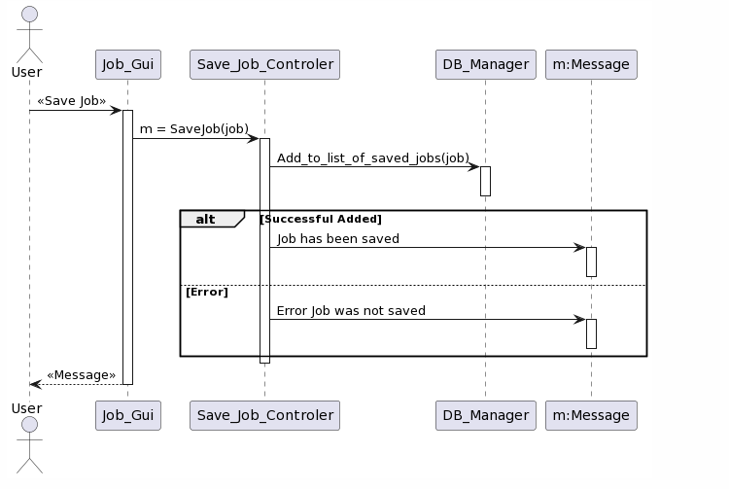

Save Job

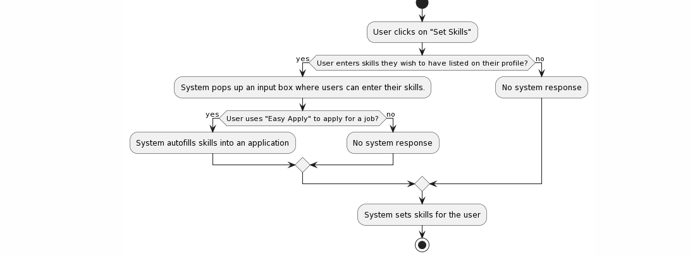

add skill to profile

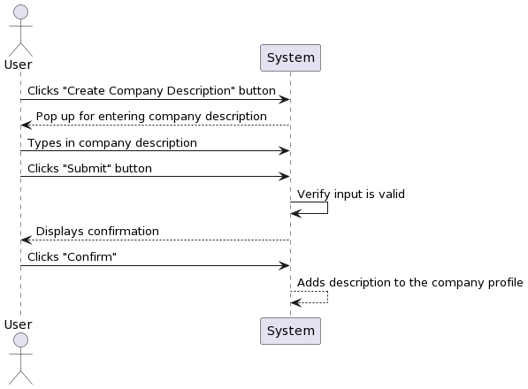

Create Company Description

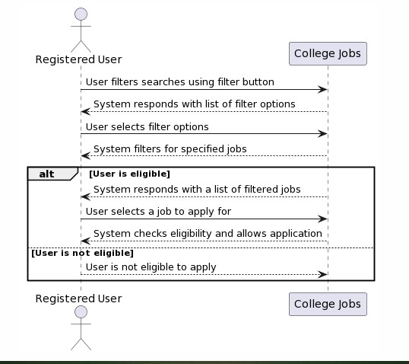

Jobs for credit

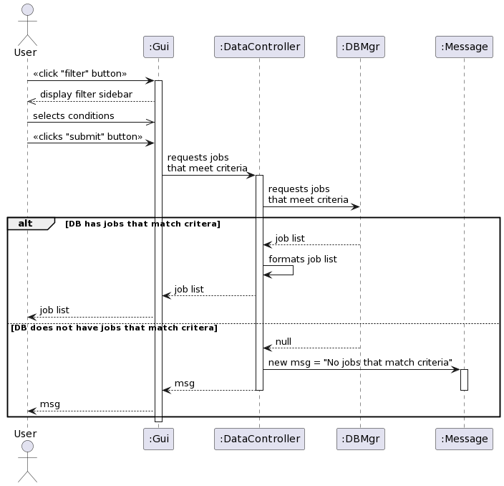

Filter jobs

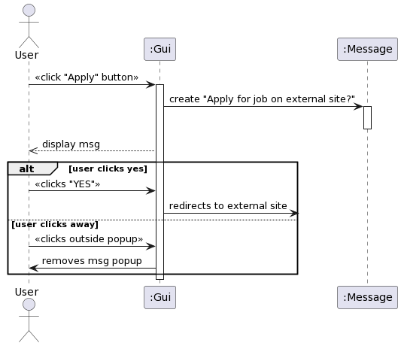

apply for job

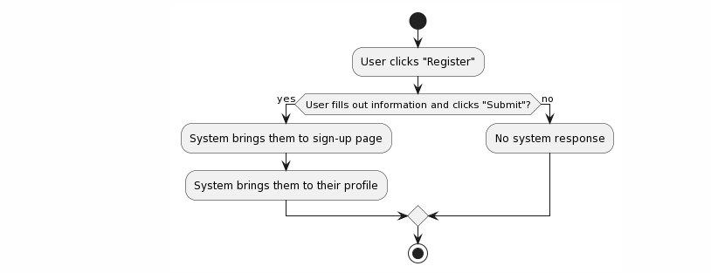

Registering

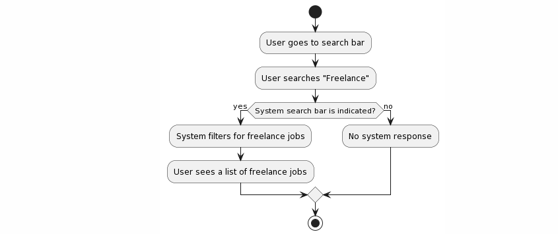

Freelance job offering

**design sequence diagrams**

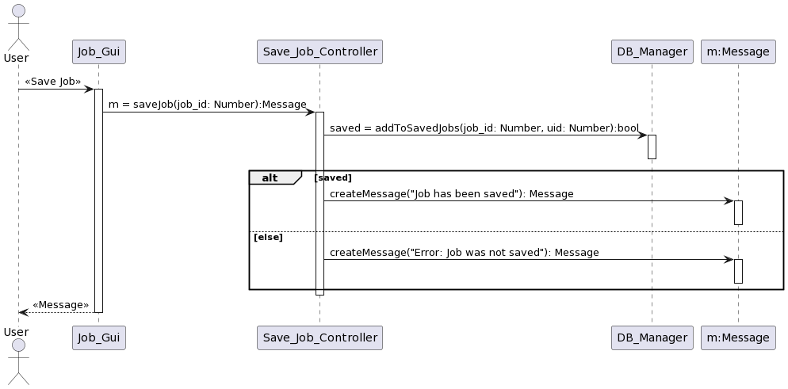

Save Job

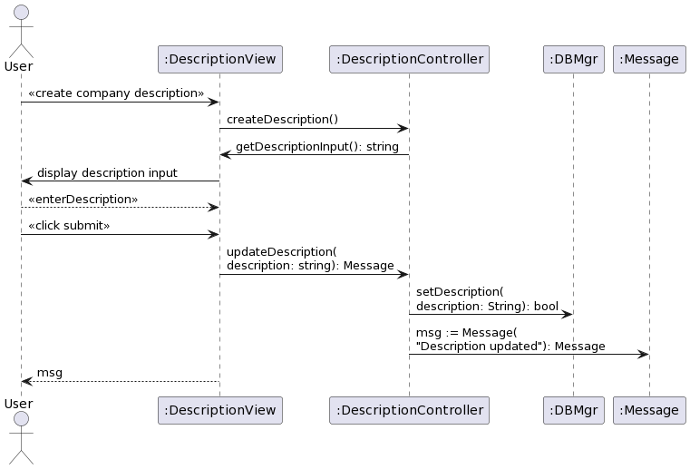

Create Company Description

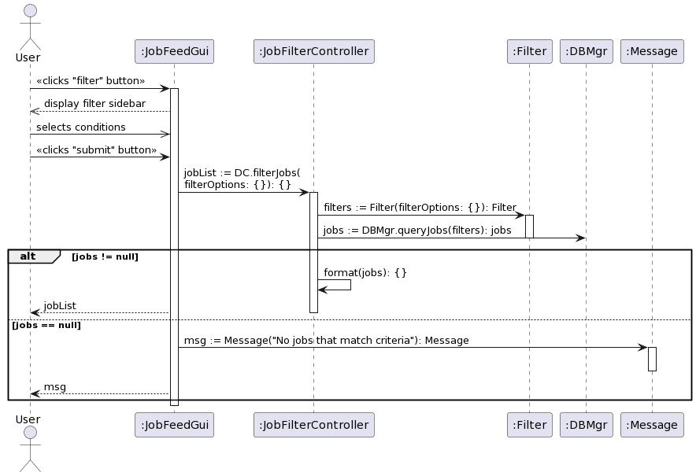

Filter jobs